Preface

This Guide is intended to be read by system administrators responsible for setting up and maintaining the parameters that govern how the system behaves. This guide covers those parameters relating exclusively to advanced workflow.

# Introduction

This chapter provides an overview of the advanced workflow system tailoring process. It explains what each aspect of tailoring involves, how it is used to set up your advanced workflows, and its role in on-going system maintenance.

## Advanced Workflow - an Overview

The system is a trade finance system that allows trade finance transactions to be processed in one comprehensive environment:

* Each type of transaction the system can process is called a product
* Each product is processed in a series of stages called events, each event representing a stage in the life-cycle of a product
* Events themselves go through steps, including log and input steps. After input, full details of the transaction are entered

The pre-delivered workflow ‘lite’ configuration provides the default sequence of steps available by default to all events. The attributes of steps, initial steps and rejection steps are defined for events within parameter sets.

Advanced workflow allows multiple instances of each default type of step to be defined. This could for example provide for two levels of logging, or repeating watch list checks:

* Log steps
* Limit check steps
* Input steps
* Watch list check steps
* Review steps (for review and authorisation)
* Print steps

The following step types are available exclusively under advanced workflow. These are described in the advanced workflow steps section:

* Exchange steps
* External review steps
* Synchronisation steps
* Auto reject steps
* Post release steps
* Final limit check steps (to support reject workflows)

Multiple instances of default and advanced step types can be organised into a main sequence (this incorporates the data capture logging, input and exchange steps). Parallel sequences can also be defined branching off the main sequence or other parallel sequences. The point at which parallel lines join back in is flexibly configurable. Note that all parallel sequences must rejoin the main line for the release step where the release items are released. Post release parallel processing is available allowing print and post release steps to run simultaneously.

Another feature exclusive to advanced workflow is the availability of reject branches. Banks may require a conditional branch step sequence for use only during verification rejection. During review/authorisation it may be required to make a small change to the data (such as the issue date). The bank does not want to reject back to an input step and then repeat all the intervening steps to release. Instead a separate rejection line can be defined within the template to execute one input, limit check and review step. These steps could be assigned to different teams and have separate step average times.

## Optional ‘Standard’ Workflow - an Overview

Banks can license an intermediate level of features between lite and advanced. Standard workflow includes all the features available in advanced with the following exceptions:

* Exchange and External review steps are not available (steps which communicate with external systems).
* Orchestration templates with parallel flows or rejection flows are not available (all templates are restricted to a linear sequence of steps).

## Advanced Workflow Phases

Advanced workflow follows the three basic phases as provided under workflow ‘lite’:

* Data capture
* Verification
* Post release

The following steps are provided by the system to provide context for mapped steps. They represent phase boundary reference points:

* Start
* Data capture
* Final limit check (to support main step sequence – not reject branches)
* Verification
* Release
* Post release
* Complete

Steps can be mapped within the phases by adding steps after Start, Final limit check or Release.

1. Advanced workflow allows steps available under verification to be set in parallel contexts such that they can execute freely in data capture or in verification phases.

Where steps are available to execute is as follows:

* Data Capture and Reject branches:
* Log steps
* Input steps
* Exchange steps
* Limit check
* Data capture, Verification and Rejection branches:
* Review steps (including final)
* External review steps
* Watch list check steps
* Synchronisation steps
* Auto reject steps
* Post release
* Print steps
* Post release steps
* Reject branch steps
* Final limit check steps

The following is an example illustrating parallel step linkages for use within transaction events:

|  |  |  |
| --- | --- | --- |
| Main Line | Branch | Reject Branch |

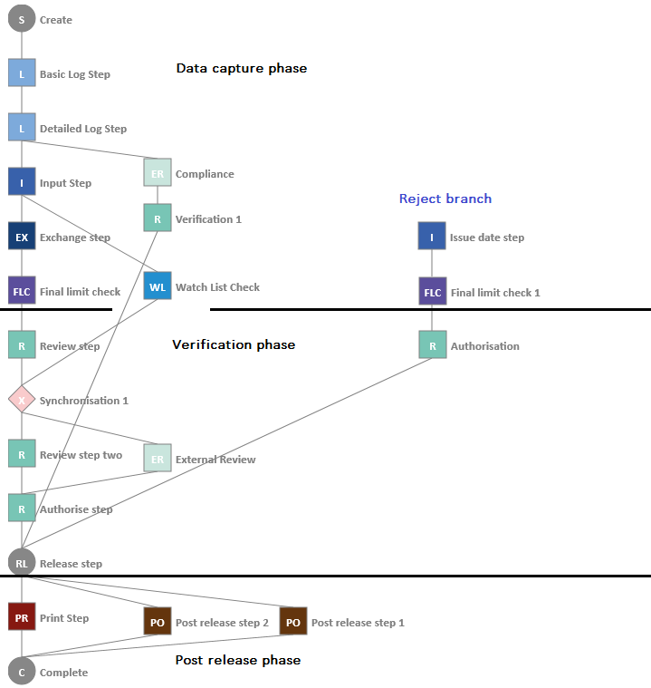

The reject branch to correct input (issue date in this example) is shown on the right.

See the SDK Workflow Implementation Guide – Trade Innovation for further details on implementing advanced workflow.

## Advanced Workflow Steps

The following step types are provided exclusively under advanced workflow. Please refer to the *SDK Workflow Implementation Guide* – Trade Innovation for gateway message response requirements, customisation setup and the user interactions available. For an event the full history of gateway messages interactions is available.

### Exchange Steps

This step type allows an external system to input data into an event in the same way as a user can within Trade Innovation. For an exchange step selected event fields can be sent to an external system via a gateway message. This is defined within the step level documents maintenance. The external system can either receive existing data and change it or receive uninitialised fields to populate. The response is received back into Trade Innovation through the gateway. The response is received back into Trade Innovation through the gateway using a specific message associated with the event (e.g. TFILCAPP for Import LC Issue, TFEGTAMD for Export Guarantee Amend) or the generic TFRCVDOC message that is available to all events. The response returned can include errors, warnings and gateway user actions. An auto-complete flag determines if the step auto-completes if there are no validation warnings or errors. A Trade Innovation user reviews the event details enriched by the data received back. The Trade Innovation user can accept the changes, reject back to a prior step, or repair the step. Repair opens up the details to edit. The step can be completed as a normal input step.

In the dashboard, before the response is received the step status is ‘Requested’.

If the response is received and the step does not auto complete, the status changes to Received – Attn reqd’ (attention required).

If the gateway response message failed to map to the step, it can be retried through message manager application’s Internal transaction messaging |External review/Exchange step messages menu option. A link to these messages is also available from the dashboard.

1. Exchange steps update the event and so cannot be run in parallel. All Log, Input, Limit check and Exchange steps must be executed in the main line of the data capture phase.

### External Review Steps

This step type allows an external system to provide a verification query response. As the exchange step selected event fields can be sent to an external system via a gateway message. This is defined within the step level documents maintenance. This data provides the verification query context information. The response is received back into Trade Innovation through the gateway using message TFEXRRSP. The response returned can include errors and warnings. An auto-complete flag determines if the step auto-completes if there are no validation warnings or errors. The response data is stored against the step (provided by step level customisation). Where user interaction is required the user can reject back to a prior step or confirm to continue.

In the dashboard, before the response is received the step status is ‘Requested’.

If the response is received and the step does not auto complete, the status changes to Received – Attn reqd’ (attention required).

If the gateway response message failed to map to the step, it can be retried through the Message Manager application’s Internal transaction messaging |External review/Exchange step messages menu option. A link to these messages is also available from the dashboard.

1. External review steps can be run in parallel with other steps and other external review steps. These can be positioned within or across the data capture and verification phases. Also available within reject branching.

### Synchronisation Steps

This step type performs no activity in itself. It is provided to cater for many to many dependencies where one group of steps must finish before the next group can start. It therefore acts as a node to bring together several parallel workflows which must be completed before the step following the synchronisation step. See Mapping Synchronisation Steps for details.

1. Synchronisation steps can be positioned within or across the data capture and verification phases. Also available within reject branching.

### Auto Reject Steps

This step type performs no activity in itself. Within the workflow orchestration, at least one rule is mandatory in the criteria and a rejection target step is required. On execution if a rule criterion is met the step automatically transitions to the rejection target step, otherwise it continues on to the following steps. Auto-rejection to multiple target steps can be managed by mapping multiple auto-reject steps in a sequence. See Mapping Synchronisation Steps for details.

### Post Release Steps

Post release steps enable senior management reviewers to view work which has been completed. This ensures the appropriate level oversight is undertaken for released transactions. Post release steps can be scheduled in parallel with each other and print steps.

# Logging On and Off

This chapter explains how to log on to the system, how to run the applications and how to exit from the system.

## Logging On

Access to the application is controlled by user ID and password. Each user is provided with one or more unique user IDs that control what applications they can access and what functionality they can use within those applications.

Before you can access the system, your security officer or user administrator must have set up at least one user profile for you to use, consisting of (among other things) a unique user ID and a password. Your security officer will tell you your user ID and password the first time you log on.

When you start the system a log-in window is displayed.

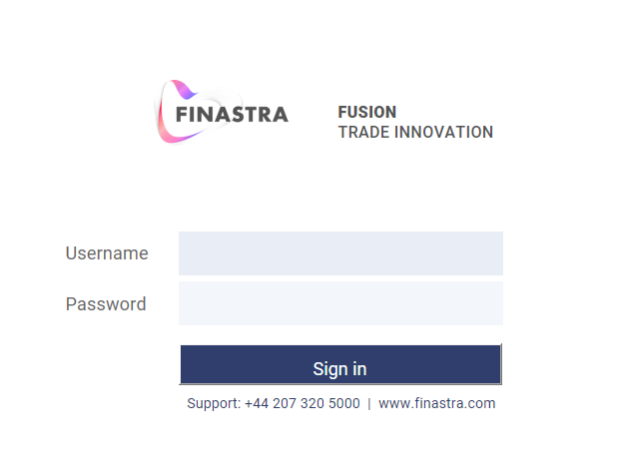

Enter your user ID and password and press **Sign in**.

Provided you have entered these values correctly, the system displays a window that lists all the zones available to you.

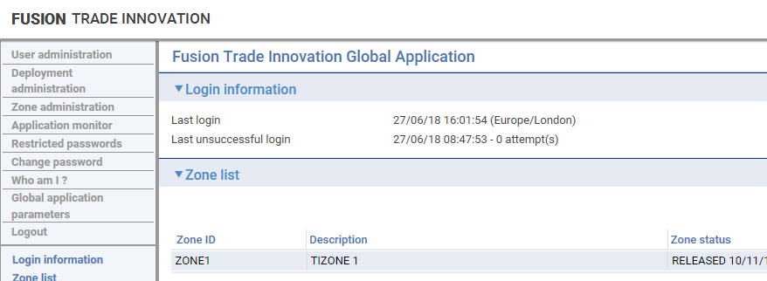

Select the zone in which you wish to work, and press **Start**. The system displays a list of all the applications available in that zone to which you have access.

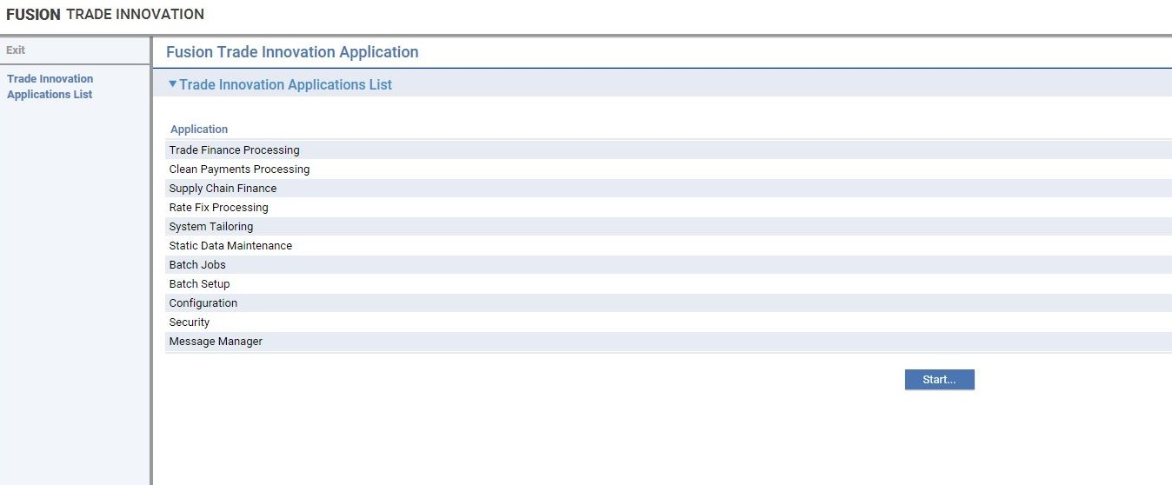

Click on the system tailoring application to open it. The system displays the menu window, which is the starting point for all workflow tailoring.

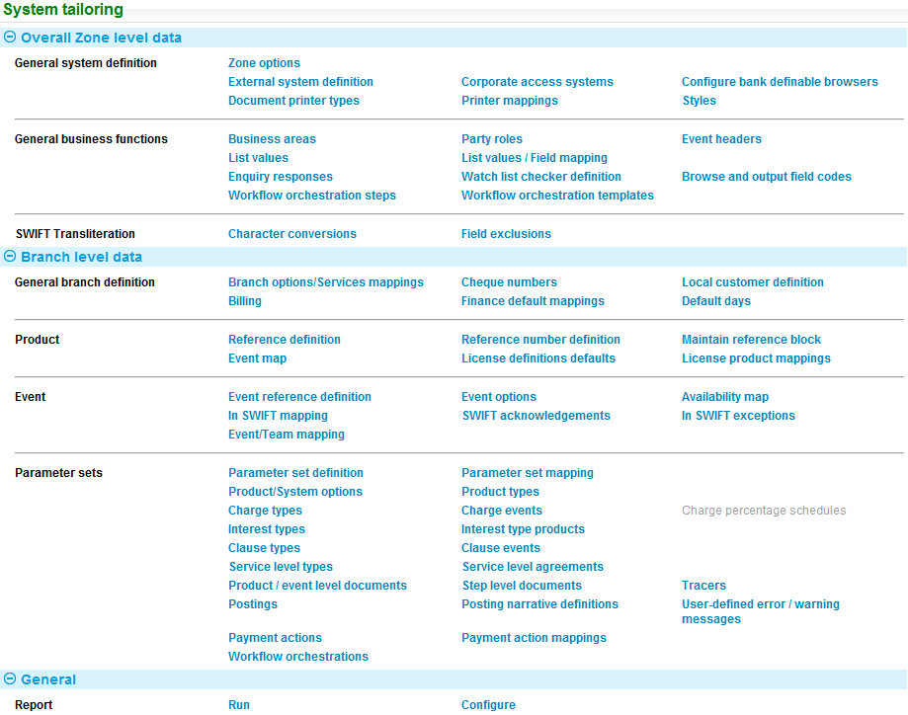

The following table shows the menu option related to workflow orchestration. For details of the other menu options, refer to the *System Tailoring User Guide* – Trade Innovation:

|  |  |  |
| --- | --- | --- |
| Menu Bar Option | Sub-option | What it Does |
| General System Definition | External system definition | Allows you to link exchange and external review services to external systems. |
| General business functions | Workflow orchestration steps | Allows you to view and maintain the full set of steps available to be mapped into an orchestration template. Note you can only create additional steps if your bank uses advanced workflow. |
|  | Workflow orchestration templates | Allows you to link the orchestration steps into a template. Note you can only create additional templates if your bank uses advanced workflow. The system is delivered with a single default template for use in all products and events. |
| General branch definition | Branch options/Services mappings | Allows exchange and external review services that are used at main banking entity (or above) to be mapped and associated service system options to be set. |
| Parameter sets | Parameter set mapping | Allows you to link a workflow orchestration parameter set to the parts of the business (branches) that will use that workflow model. |
|  | Step level documents | Allows you to define documents to export data within advanced workflow steps. |
|  | Workflow orchestrations | Allows you to create, change, delete, and map orchestration parameter sets to branches under workflow ‘lite’.  A default orchestration parameter set is provided linked to the top of all branch hierarchies within the zone. This set includes an in-use orchestration for all events licensed in the zone. (see page 9) |

# Creating and Maintaining Workflow Orchestration Steps and Templates

This chapter explains how to do the following:

* Create and maintain workflow steps
* Create and maintain workflow templates

## Maintaining Workflow Steps

With an advanced workflow, the system permits you to create, update, copy, delete and view steps to be used within orchestration templates.

The capabilities controlling these functions are defined in the *Security Guide* – Trade Innovation.

You can define a step’s description by using the system tailoring application’s General business functions|Workflow orchestration steps menu option.

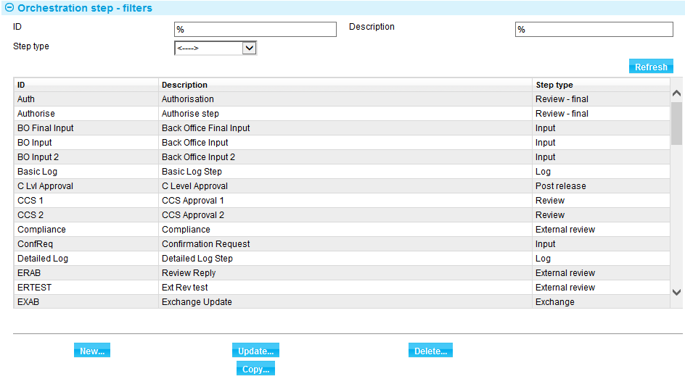

Information is shown for each step under the following headings:

|  |  |
| --- | --- |
| Heading | What it Shows |
| ID | The unique identifier of the step. |
| Description | The description of the step |
| Step type | The type category of step. |

### Creating a Step

In the Orchestration step selection screen, click **New**.

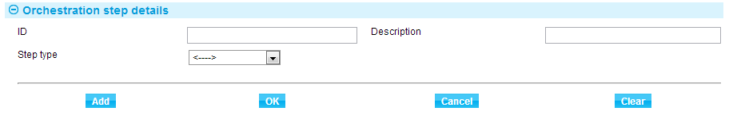

Enter the step ID and description of the step then select the step type. The step type can be any of the following:

* Exchange
* External review
* Final limit check
* Input
* Limit check
* Log
* Post release
* Print
* Review
* Synchronisation
* Auto reject
* Watch list check

Click **Add** then **OK**. You then see the new step in the Orchestration step selection screen.

1. Creating Exchange and External review steps also generate external services to be mapped to external systems.
2. Optionally external services can be defined against the system release step and mapped to external systems.

For example; where steps of these types are created:

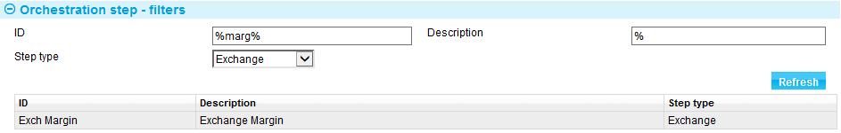

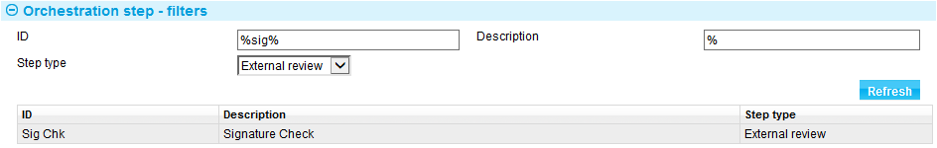

Services of type Exchange or External review are created; with a suffix of the step ID.

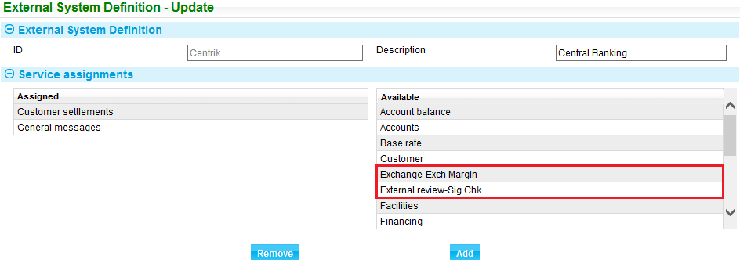

See chapter 7 for assigning services.

### Updating a Step

In the Orchestration step selection screen, click **Update**.

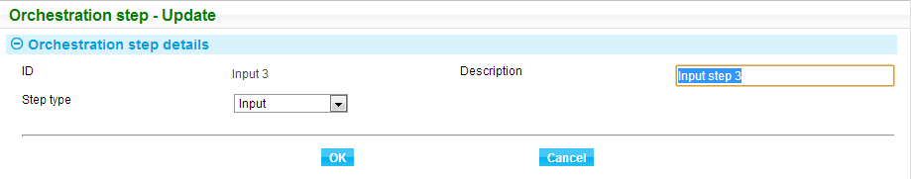

This screen allows you to change the description and select a new Step type. After you update the step, click **OK**.

If a step is currently used by one or more orchestration template, the following warning will appear.

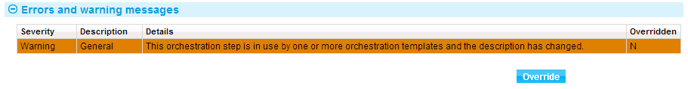

Click **Override** if you want to continue with the update. The step is now reflected on the Orchestration step selection screen.

### Copying a Step

In the Orchestration step selection screen, select the step that you want to copy then click **Copy**. This function lets you create a new step based on the description and type of the step that you want to copy. You can input a new step ID, description, and select a new step type.

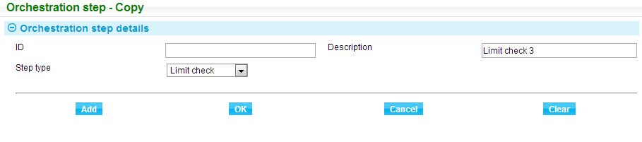

Click **Add** then **OK**. You can now see the new step in the Orchestration step selection screen.

1. Copying Exchange and External review steps also create an external service for the created step to be mapped to external systems.

### Deleting a Step

In the Orchestration step selection screen, select the step that you want to remove then click **Delete**. The following screen shows the details of the step that you want to delete.

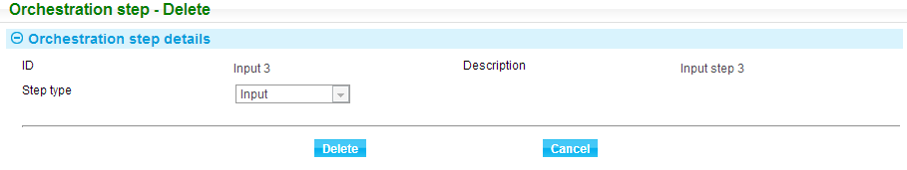

Click **Delete**.

When a step is ‘in use’ by an orchestration template, the following message is displayed and the step cannot be deleted.



If a step is not ‘in use’, a confirmation screen is displayed. Click **OK** to delete the step.

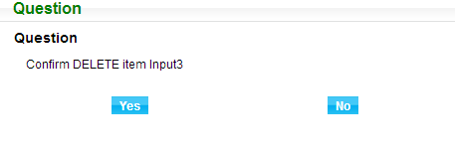

The step will now be removed from the Orchestration step selection screen.

1. Deleting Exchange and External review steps also delete the external services and any mappings to external systems. Deleting Exchange and External review steps also deletes any step level documents defined for that step identifier.

### Viewing a Step

The window that is displayed lists all of the steps that are in the system. You can use the filters to search for a step. Input your search criteria then click **Refresh**.

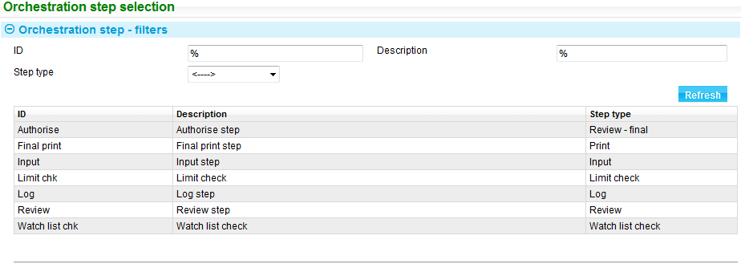

## Maintaining Workflow Orchestration Templates

With an advanced workflow, the system permits you to create, update, copy delete and view workflow orchestration templates. A template is a set of steps placed in sequential order to represent the step lifecycle of an event. The capabilities controlling these functions are defined in the *Security Guide* – Trade Innovation.

You can define a step’s description by using the system tailoring application’s General business functions|Workflow orchestration templates menu option.

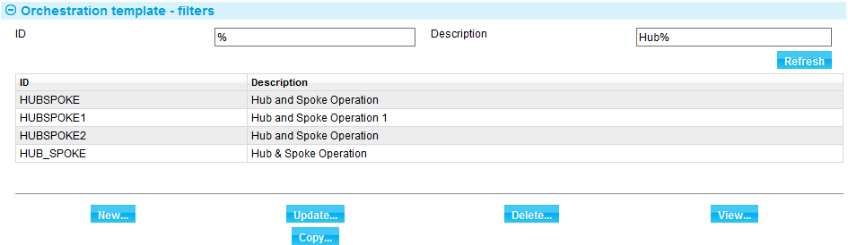

You can also use the following filters to display only the relevant templates you require:

* ID
* Description

Enter partial texts to filter the list. Click **Refresh** to apply the filters.

### Creating a Workflow Orchestration Template

In the Orchestration template selection screen, click **New**.



The following table explains what to enter into the fields in the Orchestration details pane:

|  |  |  |
| --- | --- | --- |
|  | Field | What to Enter |
|  | ID | The unique identifier of the template. |
|  | Description | The description of the template. |

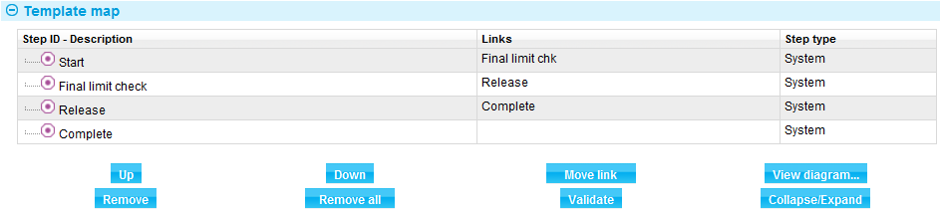

The template includes four default reference steps as starting points to link steps to.

The links column lists the step or steps which are linked directly to this step (will execute after this step completes).

Steps are added from the Available steps section. Steps should be added from the Available list before using the Up, Down, Remove, Remove all, Move link and Validate functions.

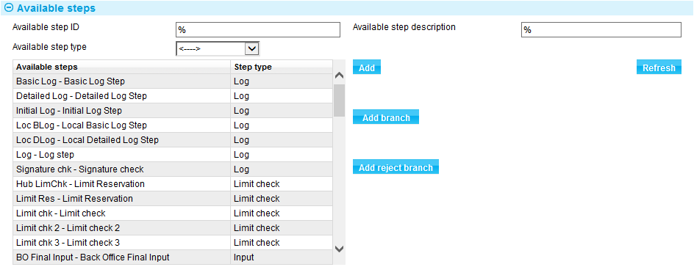

When selecting available steps, you can also use the following filters to display only the relevant steps that you require:

* Available step ID
* Available step type
* Available step description

Click **Refresh** to apply the filters.

##### Adding Steps

To add a step, click the template step you wish to add a step after, click the required available step, click **Add**.

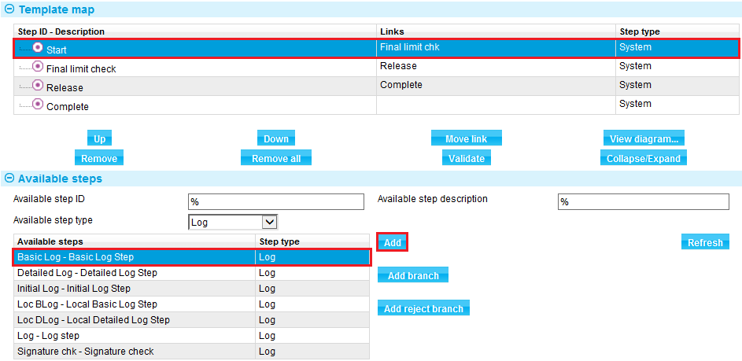

##### Adding Step Branches

After a sequence of steps has been created, steps can be created as branches from penultimate steps in that sequence.

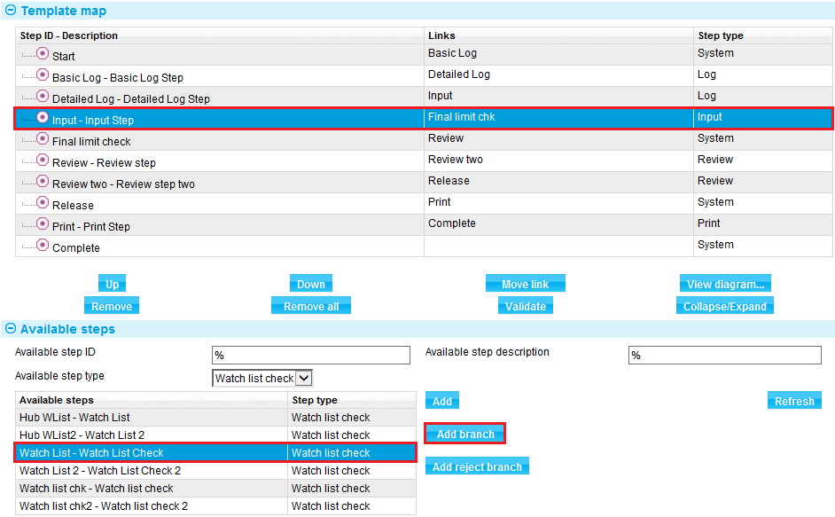

##### Adding Reject Branches

A separate sequence of steps can be set up for use specifically for verification phase rejection to correct some data (issue date in this example) and pass quickly through a single authorisation step without having to repeat the main step sequence.

1. A step does not need to be selected in the Template map for creating reject branches.

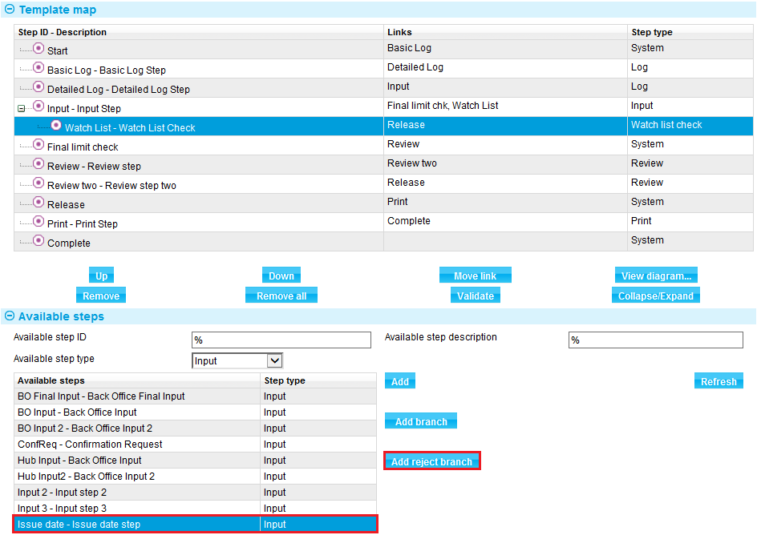

The reject branch details appear in the list after the Complete step.

1. A final limit check should also be included in reject branches.

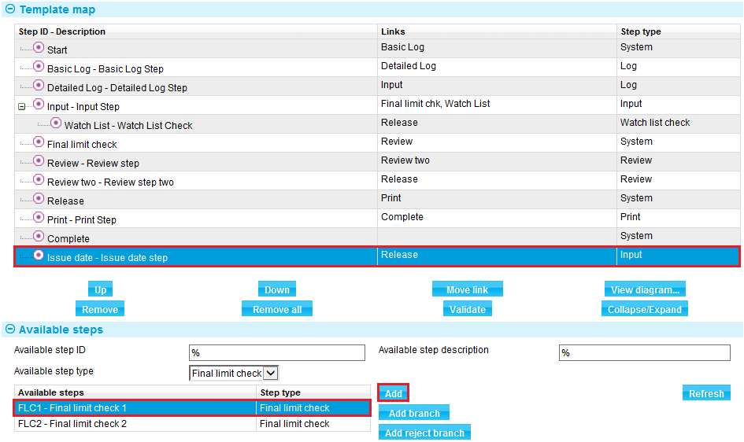

More steps and branches can be added.

The functions within the Template map allow fine tuning of the template definition.

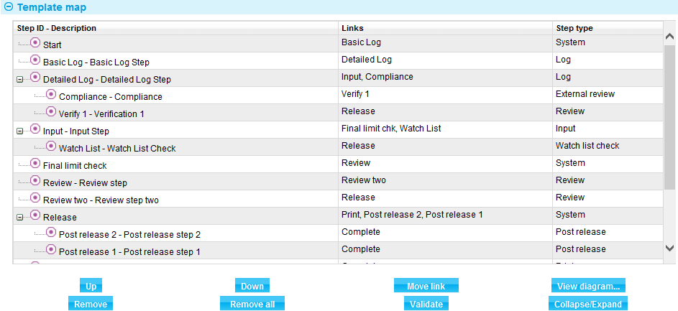

The following functions are available:

* Up – select a step and move it above the preceding step (where dependencies allow)
* Down – select a step and move it below the following step (where dependencies allow)
* Remove – removes the step from the template (and any dependent branching steps)
* Remove all – resets the template to the four initial system steps
* Move link – select a step and this button will prompt a list of all available future steps to more the dependency link to.



Validate – validate the whole template to detect all errors. Pressing **OK** against the template will also validate.

Collapse/expand – allows collapsing list to omit the branched steps for review purposes. This has no effect on the underlying template.

View diagram – a diagrammatic view of the template is provided to support understanding of the steps and their linkages.

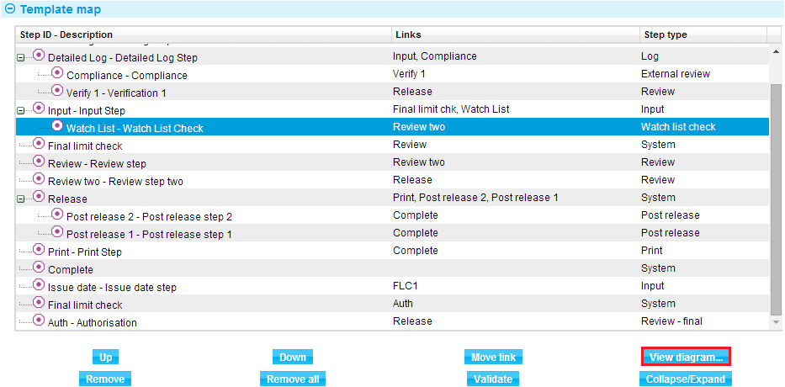

|  |  |  |
| --- | --- | --- |
| Main Line | Branch | Reject Branch |

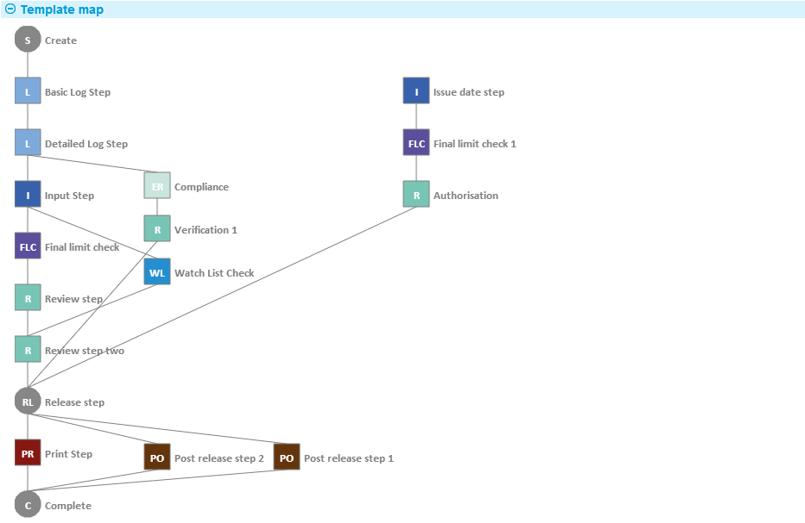

Once you have added all the steps with the required links, click **Add** at the bottom of the screen. The new template will now be available in the Orchestration template selection screen. Cancel will abandon the changes made.



##### Mapping Synchronisation Steps

In the above example it can be seen that the Release step will not execute until Review step two and Verification 1 are completed. After release the Print step, Post release step 1 and post release step 2 are available.

Synchronisation steps provide the same relationship without performing any functionality within the steps themselves.

Synchronisation steps can be added initially in a single sequence.

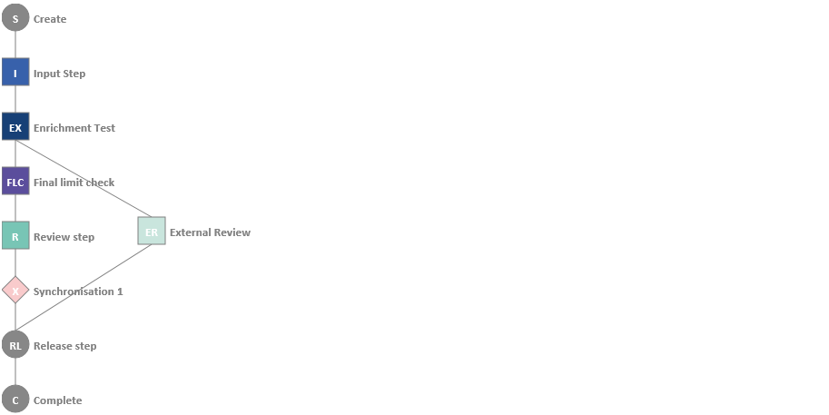

Branches above can have links moved to join into the synchronisation.

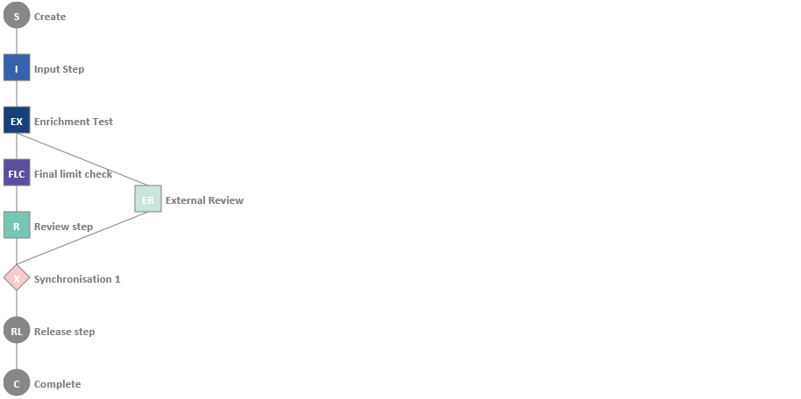

New branches can be initiated from the synchronisation step.

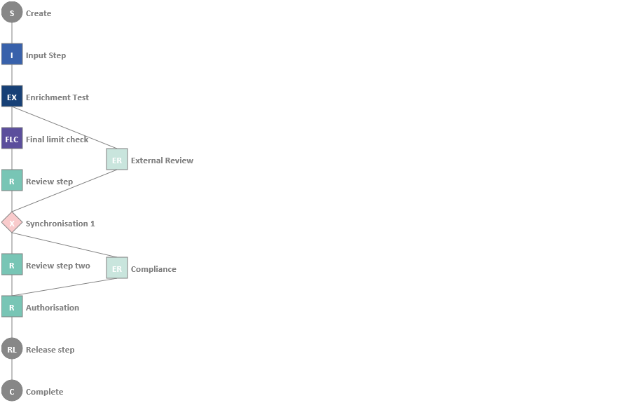

##### Mapping Auto Reject Steps

In defining complex workflows it may be required to undertake special processing under certain conditions; For example, re-setting the issue date to today prior to release of an event. This can be scheduled automatically by use of auto reject steps. The auto reject step will conditionally reject back to an input type step where the issue date <> to today’s date.

See the SDK Workflow Implementation Guide – Trade Innovation for a worked example.

Auto reject steps can be mapped as many times as required in the template main line or in rejection sequences of steps.

### Updating a Workflow Orchestration Template

In the Orchestration template selection screen, click **Update**.

The template description can be amended.

All other functions are available as under creating a new template.

Click **OK** to complete the update.

If this template is ‘in use’ in one or more orchestrations, the template cannot be changed.



Ensure no orchestrations are referencing the template before continuing.

### Copying a Workflow Orchestration Template

In the Orchestration template selection screen, click **Copy**.



A unique step ID must be entered. The description is defaulted and can be changed.

All other functions are available as under creating a new template.

Click **OK** to complete the copy with any updated changes.

If a ‘not in use’ copy of the template ID already exists at the copy destination, the template cannot be copied.



Delete the existing ‘not in use’ template before copying.

### Deleting a Workflow Orchestration Template

In the Orchestration template selection screen, click **Delete**.

If this template is ‘in use’ in one or more orchestrations, the template cannot be deleted.



Ensure no orchestrations are referencing the template before continuing.

### Viewing a Workflow Orchestration Template

In the Orchestration template selection screen, click **View**.

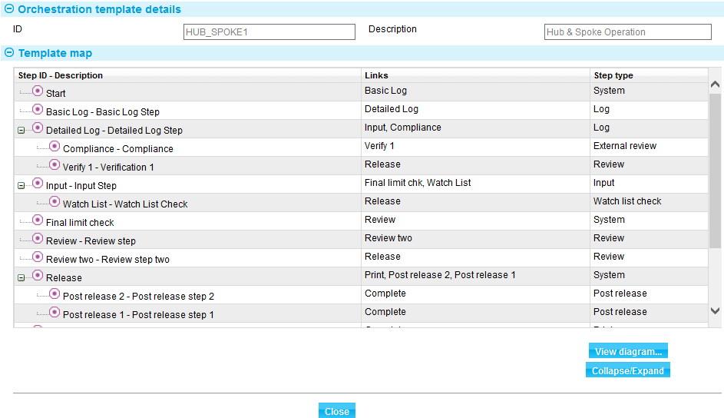

Collapse and expand functions are available (described in creating a workflow orchestration template).

The view diagram function is available (see examples in creating a workflow orchestration template).

# Workflow Orchestration

The system is delivered with a pre-defined workflow template and set of orchestrations, and the first time you use the facilities described in this chapter these are what you will see. This chapter covers the maintenance of orchestrations.

Average step times are managed within orchestrations. Service level escalation times are managed separately within service level agreements.

## Workflow Orchestration Maintenance

Workflow ‘lite’ is provided within the default Orchestrations parameter set and is configurable. See the *System Tailoring Guide* – Trade Innovation for details on maintaining the default set.

Advanced workflow permits user defined templates including parallel step dependencies to be managed. For each event and step within the event you can decide the processing conditions and expected timings for that step. These are defined within parameter sets.

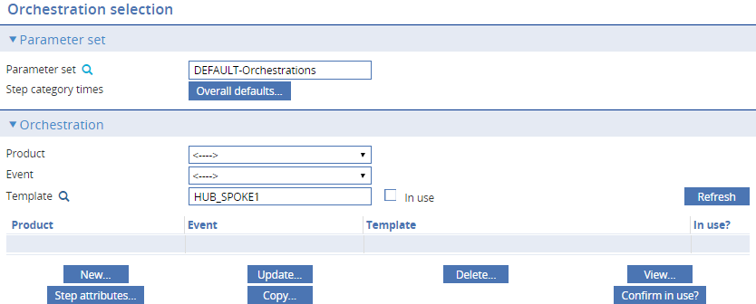

The following can be set for each event within the parameter set:

General orchestration level attributes:

* Initial steps (when created interactively, from Batch, from Gateway, and SWIFT).
* Reject to steps from the release step (when created from Batch, from Gateway and SWIFT).

Step level attributes:

* Step average times
* Step run conditions
* Target steps if event rejected from this step.

The default parameter set contains a full orchestration for each event.

### Step Times Defaults

There are three levels available for setting the step times and the times used default from a higher level:

|  |  |  |
| --- | --- | --- |
| Level | Where Set | Defaulted From |
| Overall Defaults | Orchestration selection screen –  Step category times – Overall Defaults button |  |
| Event | Orchestration selection screen –  Step category times button | Overall Defaults |
| Orchestration Step | Orchestration New/Update screen -  Assign step attributes button then Assign step time button. | Event |

Orchestration default step times are derived from the parameter set used. This is the ‘Overall defaults’ available for all products and events using that parameter set. When an orchestration for an event is created for the first time in a parameter set, these generic times map into the ‘Step category times’ for that event. The ‘Step category times’ should be tailored to the requirement of the event before use. It is important, therefore for your bank to decide on the most common processing times for events and steps to use as the overall defaults for efficiency in the setup of the subsequent event level orchestrations.

See the Creating workflow orchestrations section for details on maintaining these category times prior to defaulting them into the orchestration steps.

### The Orchestration Selection Screen

Using the menu option Parameter sets|Workflow Orchestration displays the Orchestration selection screen. This screen allows you to view, add, update, or delete orchestrations.

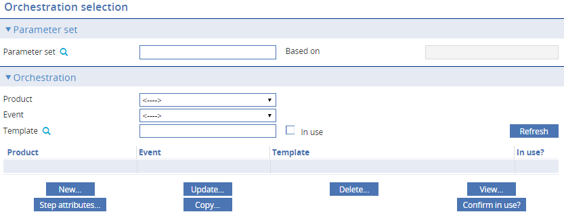

The required parameter set is selected by entering the Parameter set ID. This allows orchestrations to be added, updated or deleted for the specified Parameter set.

When you select a parameter set ID and select a product from the Product dropdown field the system displays all orchestrations already defined for the set for events and you can add to or amend them.

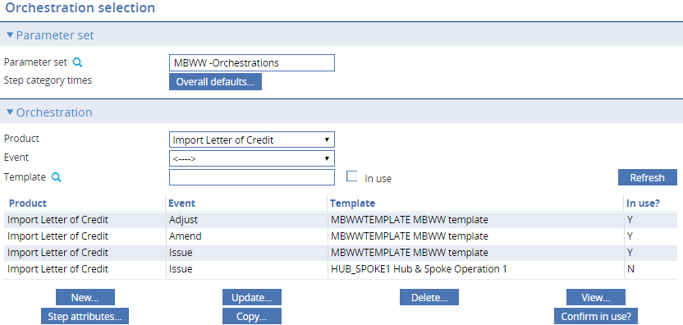

You can also use the Event and Template fields to filter the orchestrations that will be displayed.

Information is shown for each orchestration under the following headings:

|  |  |
| --- | --- |
| Heading | What it Shows |
| Product | The product where the orchestration is assigned. |
| Event | The event where the orchestration is assigned. |
| Template | The template that the orchestration is based on. |
| In use? | Orchestrations set to Y, are in use as the live definition controlling the step behaviour of created events. Orchestrations set to N, are configurable definitions available to become the live orchestration when required. |

### Creating Workflow Orchestrations

New orchestrations can be created ‘not in use’ to be made live at a later date. These can exist alongside ’in use’ orchestrations and can be made in-use when required, replacing the previous ‘in use’ definition.

Workflow orchestrations are managed with parameter sets.

Default step times can be set for a parameter set. This is the ‘Overall defaults’ available for all products and events using that set.

Overall defaults:

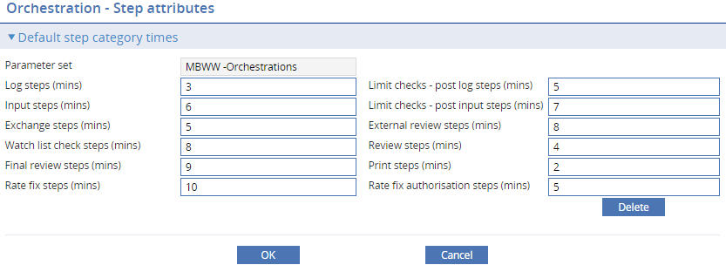

When a new orchestration is created, the ‘Step category times’ are used to default the times in to the individual steps in the new orchestration.

The step category times at the event level should be finalised in the orchestration selection screen before creating a new orchestration by pressing **Step category times**.

Event step category times:

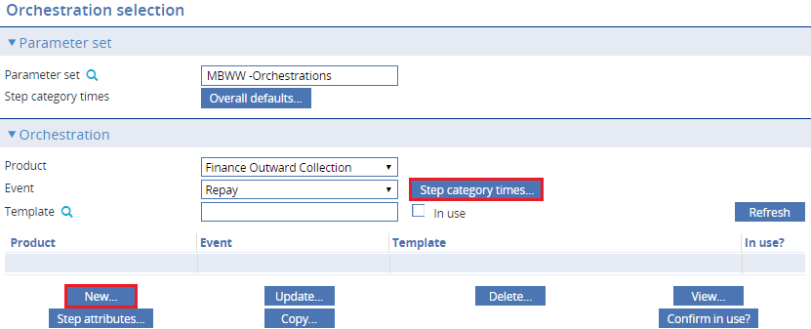

Step category times:

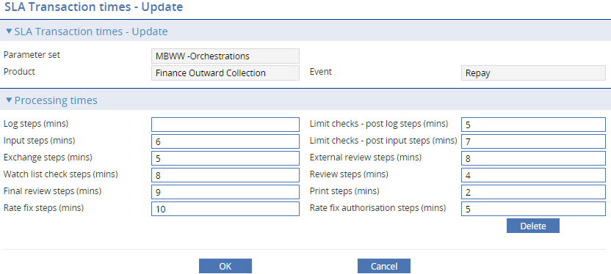

To create a new workflow orchestration, click **New**. The following table explains what to enter into the fields in the Orchestration – New pane. In this screen, the selection of the template will automatically default the average times for each step from the event step category times.

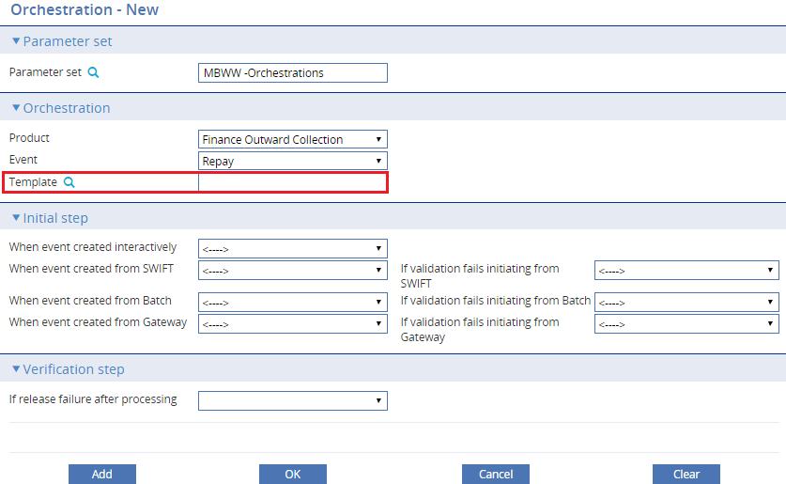

|  | Field | What to Enter |
| --- | --- | --- |
|  | Parameter set | The Parameter set to be used. |
|  | Product | The product where the orchestration will be assigned. |
|  | Event | The event where the orchestration will be assigned. |
|  | Template | The template to be used. Selecting the template will populate all of the fields in the Initial step section based on the values of the template. Step average times are populated from the event step category times. |
|  | When event created interactively | Select the step that is to be the initial step if the event is created manually.  This is automatically populated when you select a template. To change the defaults, select an initial step from the dropdown list. |
|  | When event created from SWIFT | Select the step that is to be the initial step if the event is created from an incoming SWIFT message. (However, if any of the fields in an incoming SWIFT message require attention, then the system creates the event at the reject to step for the selected step.)  This is automatically populated when you select a template. To change the defaults, select an initial step from the dropdown list. |
|  | When event created from Batch | Select the step that is to be the initial step if the event is generated during overnight batch processing. (However, if any of the fields in the batch definition require attention, then the system creates the event at the reject to step for the selected step.)  This is automatically populated when you select a template. To change the defaults, select an initial step from the dropdown list. |
|  | When event created from Gateway | Select the step that is to be the initial step if the event is created from a message received via the customer gateway interface service. (However, if any of the fields in the incoming message require attention, then the system creates the event at the reject to step for the selected step.)  This is automatically populated when you select a template. To change the defaults, select an initial step from the dropdown list. |
|  | If validation fails initiating from SWIFT | Select the data capture step that the system will reject back to if under SWIFT initiation a validation error is encountered at the initial step as defined in When event created from SWIFT.  This is automatically populated with the last input step when you select a template. To change the defaults, select a data capture log or input step from the dropdown list. |
|  | If validation fails initiating from Batch | Select the data capture step that the system will reject back to if under Batch initiation a validation error is encountered at the initial step as defined in When event created from Batch.  This is automatically populated with the last input step when you select a template. To change the defaults, select a data capture log or input step from the dropdown list. |
|  | If validation fails initiating from Gateway | Select the data capture step that the system will reject back to if under Gateway initiation a validation error is encountered at the initial step as defined in When event created from Gateway.  This is automatically populated with the last input step when you select a template. To change the defaults, select a data capture log or input step from the dropdown list. |
|  | If release failure after processing | If a user completes a review type step and release is the next step, any errors/warnings encountered in the release step will handled by the system transferring back to same review step. If however there were intervening non review steps. It cannot transfer back to a previous completed review step. Instead the ‘If release failure after processing’ step is initiated in the master browser/dashboard to continue.  Select the data verification step that the system will reject back to if a validation error is encountered at the release step (where not immediately after a review).  This is automatically populated with the last review type step in the template main line when you select a template. To change the defaults, select a verification input or log step from the dropdown list. |

After the template is populated, you can also assign the steps’ step times, step conditions, and reject steps by clicking **Assign step attributes**. This is discussed further in the following section.

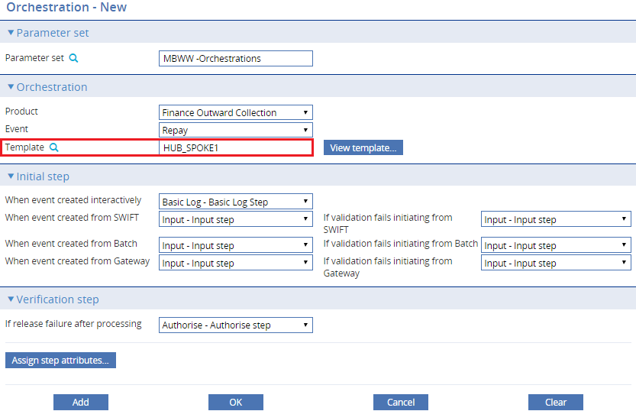

Click Assign step attributes.

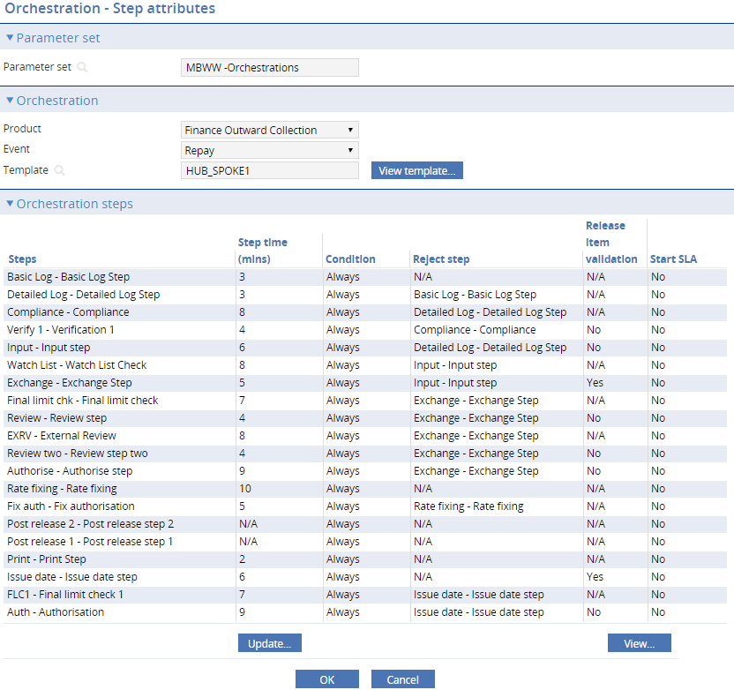

All step details are presented pre-defaulted. An update function is available against each step for configuring step attributes.

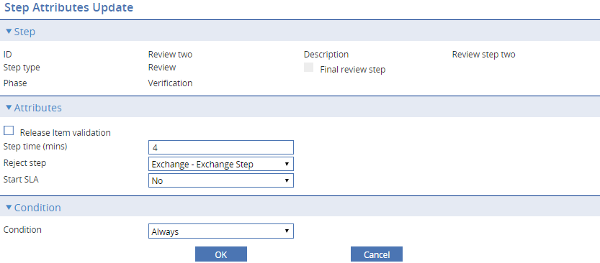

Where applicable for each orchestration step, the step attributes & conditions screen allows you to do the following:

* Release item validation
* Assign SLA step times
* Assign reject target steps from this step
* Start (restart) the SLA from transitioning through this step
* Assign step conditions

1. Orchestrations flagged as ‘In use’ cannot be modified.

##### Configuring release item validation

##### The ‘Verify batch’ release item validation against the back office is triggered automatically at release. Where banks require this check at other points in the workflow the validation can be set in the required orchestration steps. This is available to input, exchange and review type steps.

Tick the Release item validation box, then click **OK** to complete the change.

##### Configuring SLA Step Times

Individual step times are defaulted from the step category times for the event. To update an individual step time, select a step then click **Update** for the selected step.

Modify/set the step time, then click **OK** to complete the change.

##### Assigning Reject Steps

Reject steps are the data capture step the event returns to when you press **Reject** on any Review or Authorise step. By default, rejected steps are sent to the last input step. You can change where rejected steps will be sent by selecting a step and clicking **Assign reject step**.

Select the step from the Reject step dropdown then click **OK** to complete the change.

1. The capability OrchestrationAllowRejectSelect will allow a user to reject back to any valid previous step as within the dropdown above. The step selected in the orchestration is the default.

##### Starting the SLA countdown from the current step

In certain instances a conditional step in the workflow may represent preliminary processing, after which the SLA should logically commence. The SLA always starts from event creation, triggering from the step will ‘reset’ the SLA countdown. The following options are allowed:

* No (default) – SLA countdown is not affected
* At step entry – SLA is reset immediately if this step is triggered
* At step entry or bypass – SLA is triggered if step is triggered or bypassed due to set conditions.
* At step exit – SLA is reset after user/external interactions are completed in the step
* Select the Start SLA condition from the dropdown then click **OK** to complete the change.

##### Configuring Step Conditions

To assign a step condition to a step, select a step then click **Assign step condition** for the selected step phase.

From the dropdown list, select the step condition then click **OK**. You can select from the following:

* Always – step is always executed
* Never – step is never executed
* Criteria – step is executed if one or more conditions are met

When you select Criteria, the following screen is displayed:

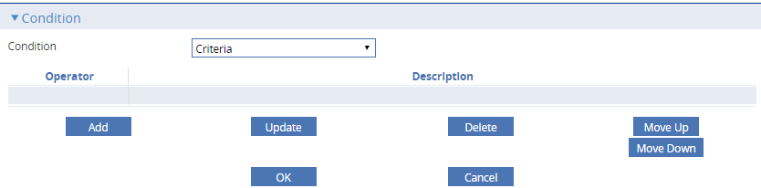

This allows you to add, update, delete, and order the step criteria. Click **Add** to create a new step condition. This can be used, for example, to only carry out the step if an amount is over a certain value or for specific currencies, customers or terms and conditions in the event data.

Configure the step criteria as needed then click **OK**.

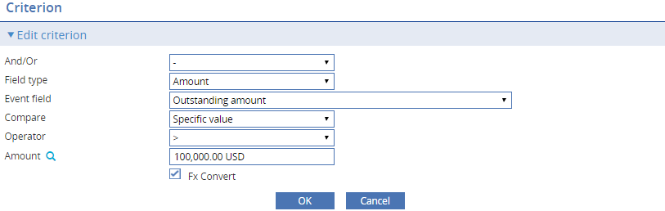

For more information on condition criteria available, see Appendix A for the Rules Facility in the System Tailoring User Guide - Trade Innovation.

##### Viewing Step Details

To view step’s orchestration attributes, select the step then click **View**.

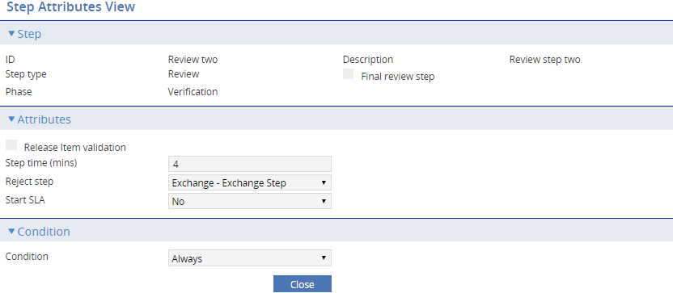

Press **Close** to exit.

##### Viewing the Underlying Template

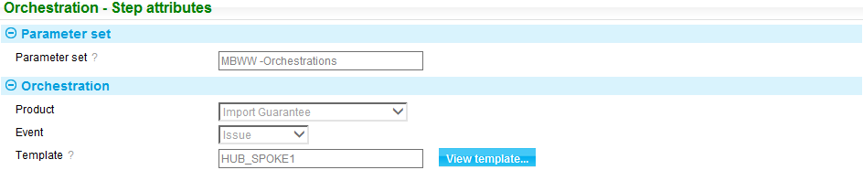

The Orchestration maintenance only manages steps which have step times, conditions or reject steps. Start, Release, Complete and any synchronisation steps are required by the system but are omitted from the list of steps that you can configure. The user can browse the full details of the template by pressing **View template**.

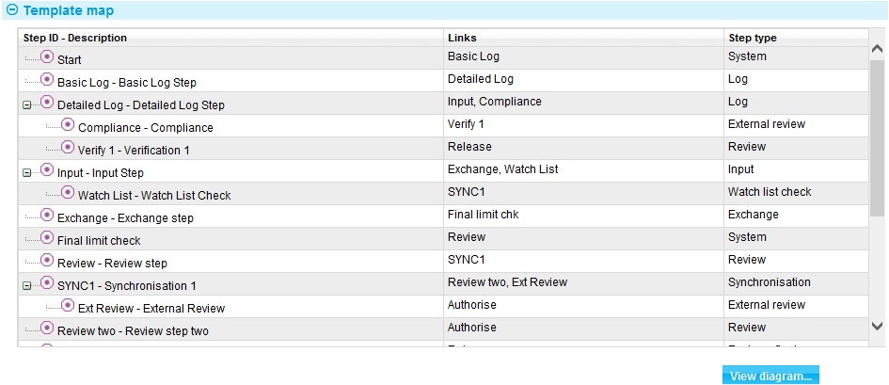

From here the template diagram can also be viewed by pressing **View diagram**.



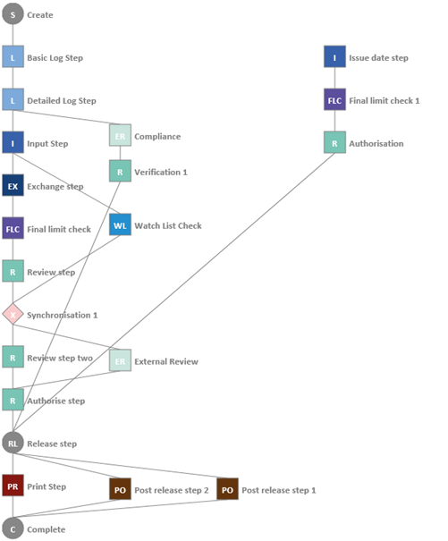

### Updating Workflow Orchestrations

To update an in-use orchestration so that the changed details apply to new transactions, the following steps are required:

* Create a new ‘notinuse’ orchestration. This can be achieved by creating a new orchestration or copying one. All copies are created ‘notinuse’.
* Update the details as required for future business.
* Set the new ‘notinuse’ to ‘inuse’. This set the new details as ‘inuse’ for future transaction. Incomplete transaction continued with the previous orchestration as obsolete.

1. When selecting a new template to apply to an orchestration, all the general and step attributes are re-defaulted. This is also the case for steps which were in the prior template.

The following table explains what can be entered:

|  |  |  |
| --- | --- | --- |
|  | Field | What to Enter |
|  | Parameter set | The Parameter set is view only. |
|  | Product | The product is view only. |
|  | Event | The event is view only. |
|  | Template | The template to be used. |

Click **OK** to save the changes.

1. Orchestrations flagged as ‘in use’ cannot be modified.

### Copying Workflow Orchestrations

1. If a parameter set is copied, the orchestrations within it are not copied to the new set. The new set is empty. Individual orchestrations can be copied from one parameter set to another using the copy function.

The copy function provides the following: Orchestrations can be copied from one parameter set to another; one product to another or one event to another. The template can also be changed. To copy an orchestration, select an orchestration then click **Copy**.

Copied orchestrations are created ‘not in use’ to be made live at a later date.

The following table explains what can be entered:

|  |  |  |
| --- | --- | --- |
|  | Field | What to Enter |
|  | Parameter set | The target parameter set to which this orchestration will be copied. |
|  | Product | The target product to which this orchestration will be copied. |
|  | Event | The target event to which this orchestration will be copied. |
|  | Template | The template to be used. |

Click **OK** to save the changes.

1. Orchestrations flagged as ‘in use’ can be copied. The copy is created ‘not in use’.

### Deleting Workflow Orchestrations

You can delete an orchestration by selecting the orchestration that you want to delete and clicking **Delete**.

1. Within the default parameter set, orchestrations flagged as ‘in use’ cannot be deleted.

### Viewing Workflow Orchestrations

You can view an orchestration by selecting the orchestration that you want to view and clicking **View**.

# Creating and Mapping Orchestration Parameter Sets

## Creating Orchestrations Parameter Sets

All event workflow orchestrations are configured within an Orchestrations type parameter set. To create a new parameter set use the system tailoring application's Parameter Sets|Parameter Set Definition menu option. Use the type filter to work with Orchestrations the parameter sets.

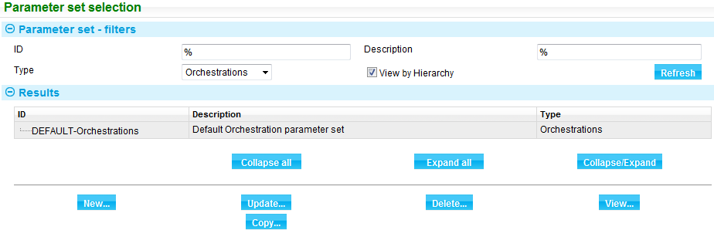

To create a new Orchestrations parameter set click **New**.

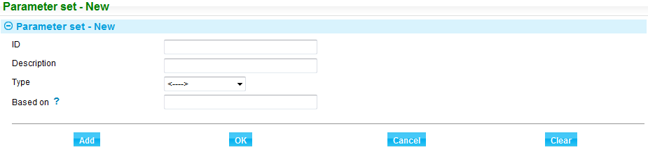

|  |  |  |
| --- | --- | --- |
|  | Field | What to Enter |
|  | ID | The unique identifier of the parameter set. |
|  | Description | The description of the parameter set. |
|  | Type | Select type Orchestrations. |
|  | Based on | Based on is not used for orchestrations. Sets do not override details based elsewhere. Complete orchestration details are set for each event in each parameter set. However based on can be used for management grouping purposes. |

See the *System Tailoring User Guide* – Trade Innovation for full details on parameter set maintenance functions.

## Mapping Orchestration Parameter Sets to Branches

Workflow orchestration parameter sets are mapped to the branches that will use them using the system tailoring application's Parameter Sets|Parameter Set Mapping menu option. The window that is displayed lists all the branches set up by your bank, and shows any parameter sets already mapped to them and their type.

Selecting Orchestrations from the Type dropdown field shows all the branches using orchestration parameter sets.

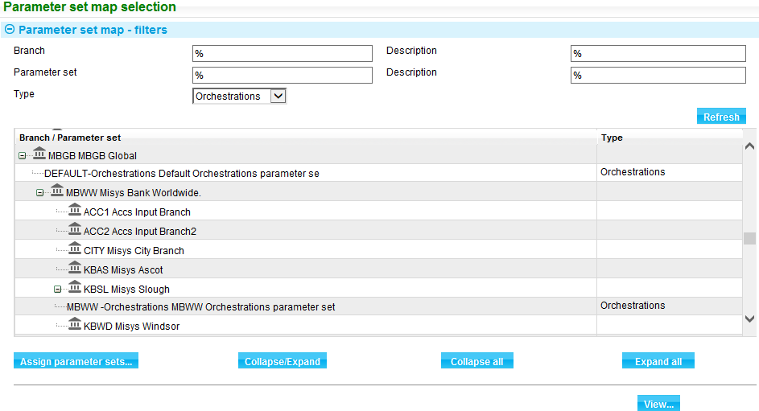

To create a new mapping, highlight the relevant branch, then press **Assign Parameter Sets**.

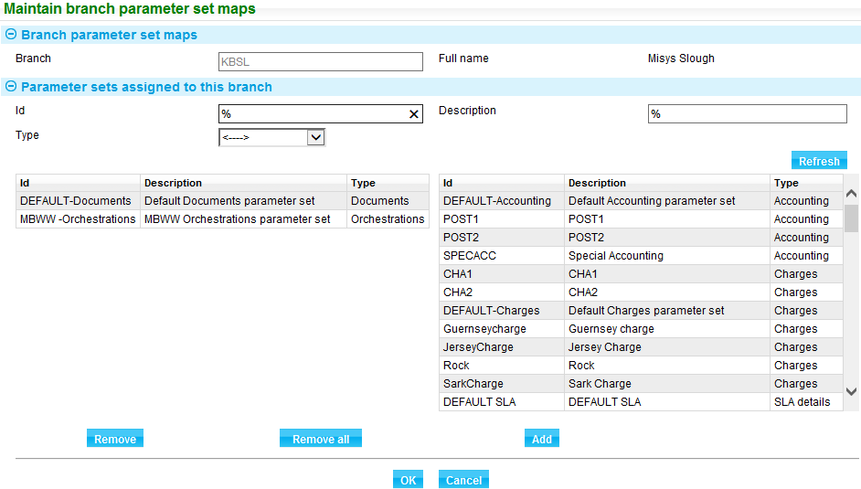

The window displays any mappings already made in the list to the left of the Parameter Sets Assigned to This Branch pane.

For each branch you can map a single parameter set ID of each type. If you do not map a parameter set ID of a particular type to a branch, it inherits the parameter set of that type from its parent in the bank's branch hierarchy.

The ID, Description and Type field are filter fields that allow you to set criteria to help you find the parameter set ID you want to map to the branch.

Use the Type field to select the type of parameter set that will be used to map to the branch. Select Orchestrations then click **Refresh**.

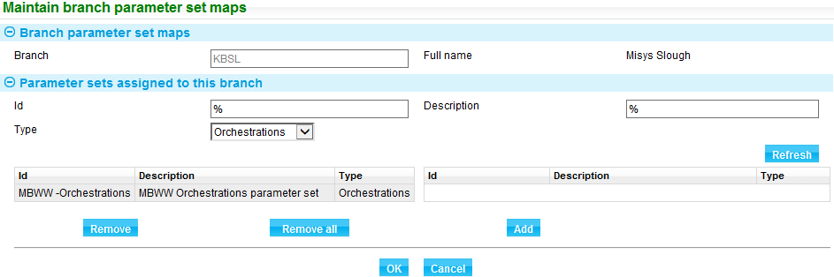

To remove a mapping, select the relevant entry in the list to the left. Then press **Remove**. The Remove All button removes all parameter set IDs mapped to the branch.

Once the mapping is removed, available sets of the type Orchestrations appear.

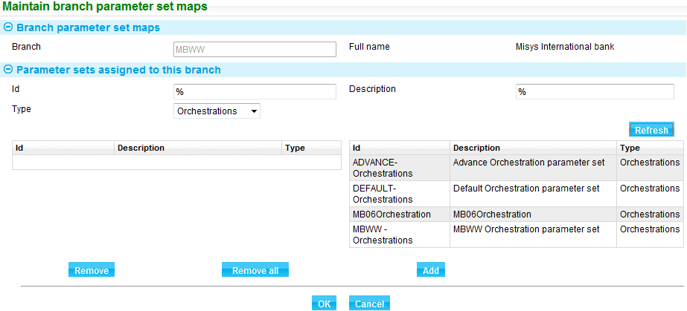

To map a parameter set ID to the selected branch, highlight it in the list to the right of the Parameter Sets Assigned to This Branch pane and press **Add**. It is moved from the right list to the left; the right-hand list is cleared of other parameter set IDs of that type.

# Step Level Documents

Step level documents are used to support interaction with external systems. Step level documents hold the event fields to be transmitted externally via gateway messages in a similar manner to watch list checker document checker definitions or customer gateway documents sent to corporates. Documents are set up for each step identifier in which they are used. Documents can be set up for the following step types:

* Exchange steps
* External review steps
* Release step (internal step in all workflows)

For each exchange, external review or release step it provides instructions on the event details to be transmitted to external systems. The external system will use the information received to determine the response back within the step:

* For exchange steps, any transaction core or customised event fields can be sent and updated or initialised by the external system, and returned to Trade Innovation. This data is then validated as a standard input step and updates the event data.
* For external review steps, transaction core or customised fields are not updated. The data returned is a response or set of responses to the event data sent. The response fields are defined separately within step level customisation. The responses are stored against the step and facilitate pass/fail conditions to proceed to the next step in the workflow.
* For the release step, any transaction core or customised event field can be sent, however no response is expected. This permits an external system to receive required information on completed transactions for an external enquiry or workflow.

## Step Level Documents

Step level documents provide the event data to be transmitted to an external system. Before you begin using documents your bank will need to have associated the external service of the step with an external system. Then the service can be assigned to the branch main banking entity controlling the required part of the business.

Each step level document, for use exclusively within the associated step, is defined in the system as a step document type either generically for all products or against a particular product and event within a parameter set. As you create each step document type, you can specify:

* Whether its generation is to be dependent on rules
* How to determine the transmission method the system is to use when generating the document - whether this is the method specified in the addressee's address details or the transfer method specified in the event

### Step Level Documents and Product and Events

When a step is initiated in an event the document to be used is determined using the following hierarchy of checks against the step identifier until a document is identified:

* A document under the product and event of the transaction, which matches any rules defined.
* A generic document (under blank product and event) which matches any rules defined.
* Continue search up the parameter set hierarchy where applicable.

For exchange and external review steps, if no matching document is found an error is reported in the step.

If through checking, more than one matching document is found, also passing any rules, an error is reported. A step must always send one request (using the single document definition) through the external service. The external service can be linked to multiple external systems. But the response back from the request must be consolidated into a single response message to the system.

## Defining Document Types

To define the document types a particular product and event will use, select the Parameter Sets|Step level documents menu option.

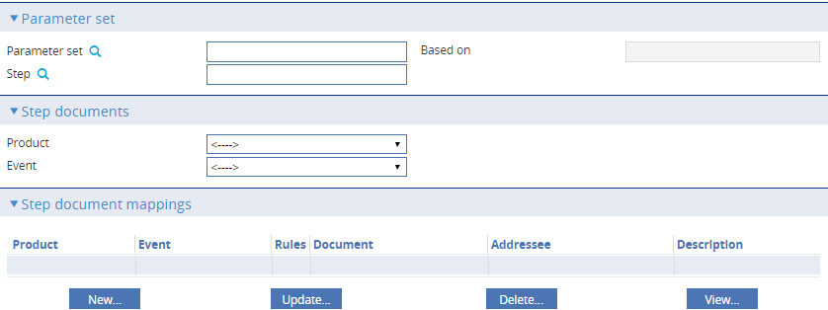

Select a parameter set ID. Select the Step. The ? function allows filtering by partial ID, description and by step type.

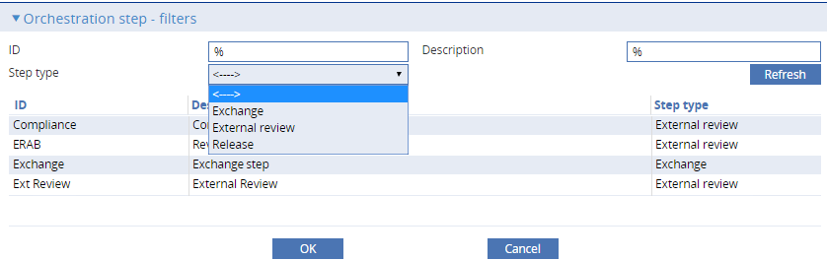

The system lists the document types already set up for that parameter set and step. You can narrow the list to those set up for a specific product or product/event combination by selecting values in the Product and Event fields.

The step documents pane, when selecting for all products and events shows generic documents for all products and events (both blank) and documents defined for specific documents and events.

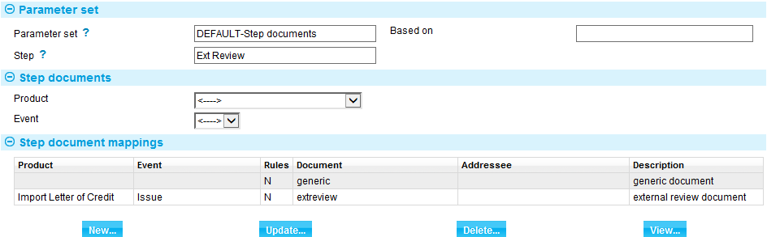

1. Documents can be defined for all products and events or a product and event combination.  
     
   The Document Mappings pane lists document types. Document types can be amended and deleted from within this pane in the usual way.

For each document type, the Document Mappings pane displays information under the following headings:

|  |  |
| --- | --- |
| Heading | What it Shows |
| Product | The product to which this document applies. Blank applies to all products. |
| Event | The event to which this document applies. Blank applies to all events. |
| Rules | Displays Y if there are rules set governing when the document should be produced, and N if there are no rules. |
| Document | The document identifier, which is unique within this product/event combination. |
| Addressee | The addressee, which will be a field taken from the event. |
| Description | The document type's description. |

If the selected parameter set has a parent parameter set, then additional information is shown, indicating which individual document types have been inherited, and which of the inherited ones have been amended or deleted from this particular parameter set).

To define a new document type for the product/event combination, press **New**.

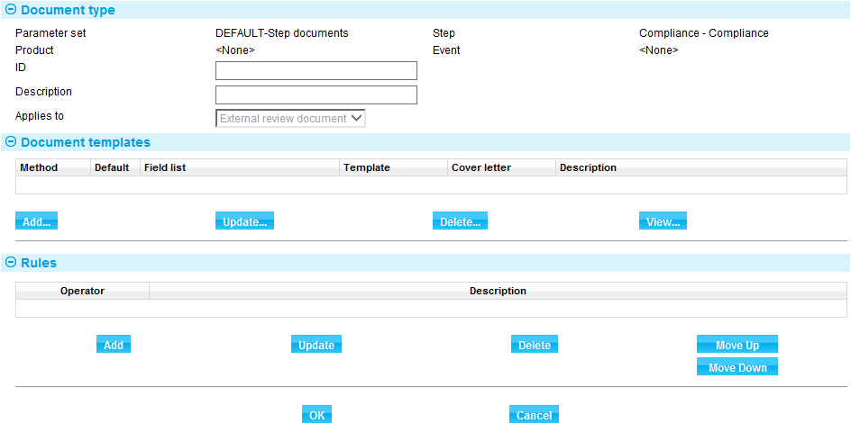

You can use the window that appears to enter information for each transmission method the event will use. You must enter information for each of the different methods of transmission your system will use to transmit documents of this type.

The Add button in Document Templates pane allows you to define the templates to be used for gateway messages. Once defined, details are listed here and can be amended or deleted in the usual way.

The Rules pane is used in the usual way to configure documents types so that they are used only if certain conditions are met. See Appendix A of the *System Tailoring User Guide* – Trade Innovation for full details.

The following table explains what to enter into the fields in the Document Type pane to define the document type:

|  |  |
| --- | --- |
| Field | What to Enter |
| ID | A unique identifier for the document type for this product/event combination. |
| Description | An alphanumeric description of the document type, indicating its purpose. |
| Applies To | This relates to the type of the step selected. Information only:   * Exchange document * External review document |

### Document Types Using Templates

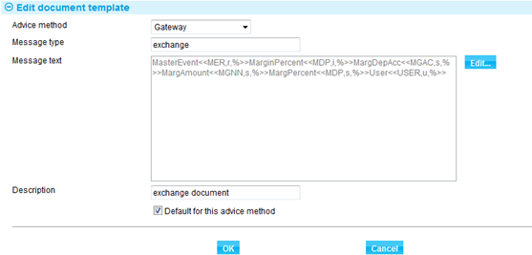

The advice method defaults to Gateway. This is the recommended standard method of communicating with external systems. If an alternate advice method is selected refer to the instructions for the equivalent method for the Parameter Sets|Product / event level documents menu option in the *System Tailoring User Guide* – Trade Innovation.

The following table explains what to enter into the fields in this window to define a transmission method using a template:

|  |  |
| --- | --- |
| Field | What to Enter |
| Advice Method | The transmission method. Select one of the following:   * Gateway – recommended – normally used. * Internal mail * Mail * Telex * Telex via SWIFT * SWIFT * No doc required * E-mail * E-mail account officer |
| Message Type | A meaningful identifier for the document. |
| Message Text | The messages content. A combination of free format text and the data base field references. Select Edit to populate the text. |
| Description | A description of the template, indicating its purpose. |
| Default for This Advice Method | Check this field if the template is the default for this transmission method. The system sets the first template you attach to this transmission method as the default, and this only changes if you check this field while attaching a subsequent template. |

The Edit button presets a window which permits you to define the content of the message.

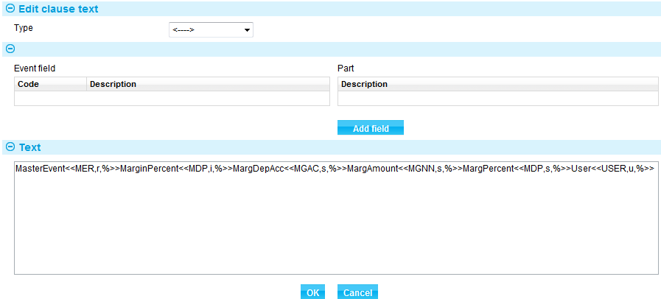

Each message is constructed of free format text (entered into the Text field) interspersed with the database fields. Event fields are accessed by selecting a field type in the Type field. The system displays a list of fields of that type available for inclusion in the message in the Fields pane.

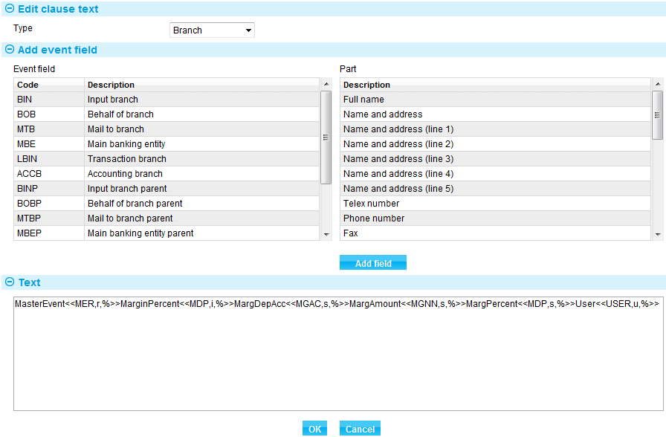

If the field type has sub-parts these are displayed in the Part pane.

To include a field in the message, select the field (and part, if relevant) and press **Add** **Field**. The system includes the field code for that field in the Text field. Manually add a label narrative before each added field code.

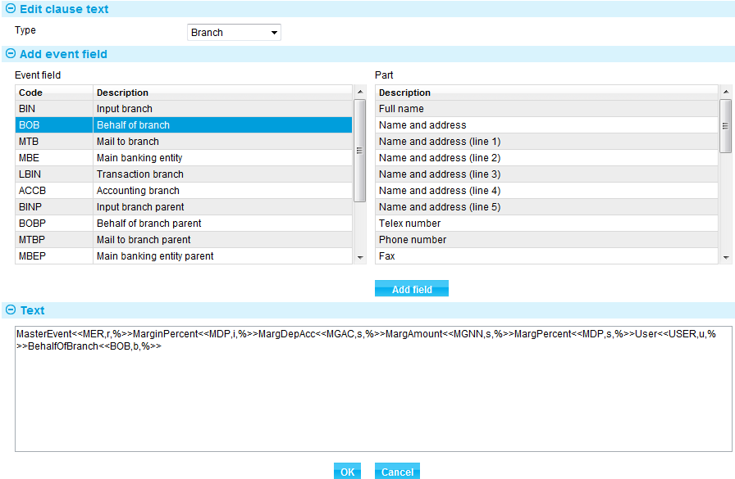

If you select 'Table' in the Type pane, the display changes.

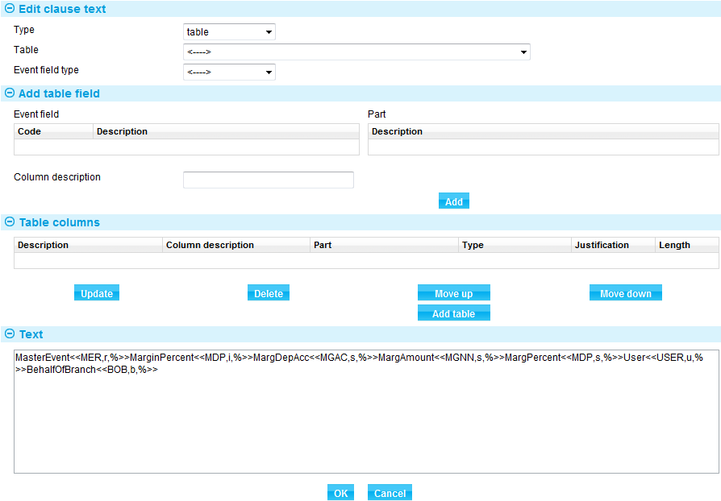

Use the Table field to select the actual table, and the Event Field type to select the field type.

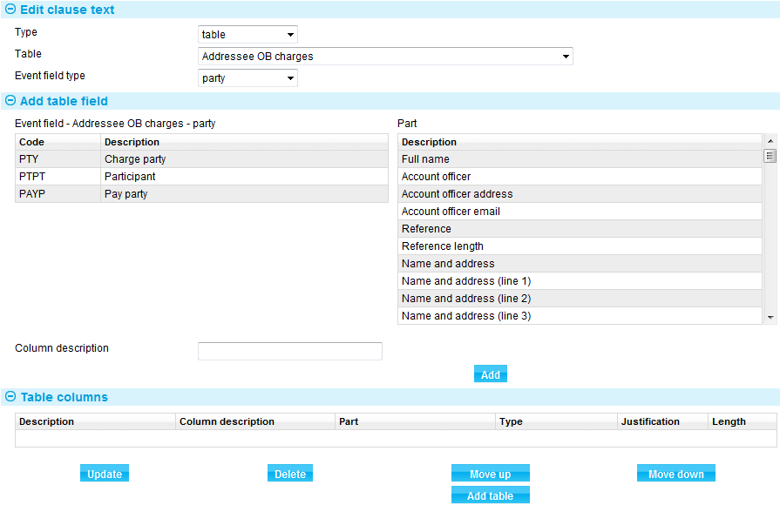

As you select a field (and part, if relevant) use the Justification field to select left or right justification and the Length field to set its length. Press **Add** to enter it into in the Table Columns pane. Each table column requires a reference added manually.

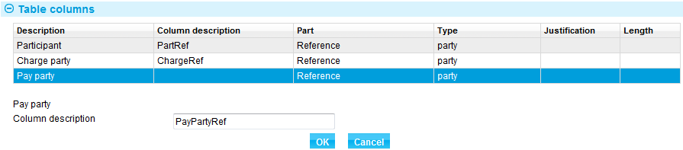

When you have selected all the fields from the table, use the Move Up and Move Down buttons to arrange them into the correct order, then press **Add Table** to add the table to the message. Then add a label narrative prefix as the other field codes.

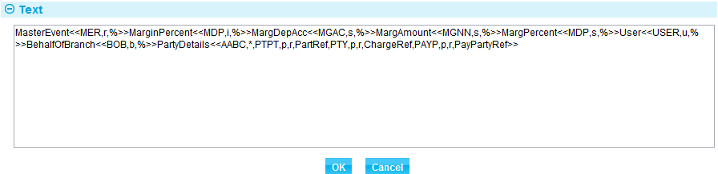

# External Services Mapping

All exchange and external review steps include a service to be mapped to an external system. The external system is included in the gateway message Target System header destination field.

Optionally the service Release notification is provided to be mapped to an external system to send a gateway message.

## Defining External Services

For example; where the following exchange and external review steps exist:





Services also exist as either:

* Exchange – (step ID)
* External review – (step ID)

You can map the services to external systems using the system tailoring application’s General system definition|External system definition.

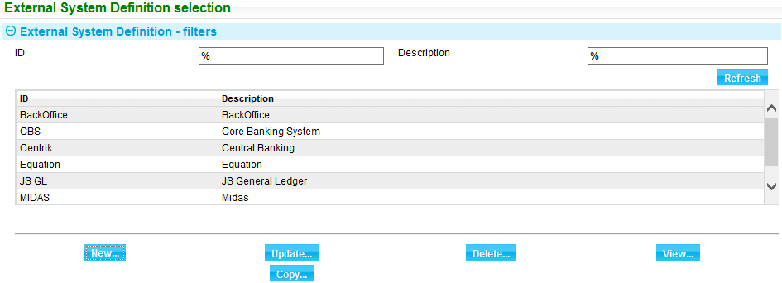

The permanent service, Release notification can be assigned to external systems for use in sending gateway messages on release of transactions.

* Release notification

Select the external system the service should apply to:

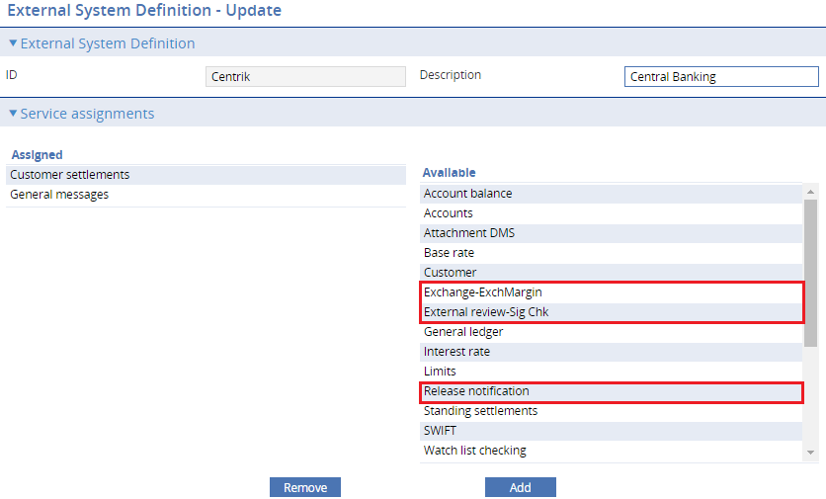

Map in the required service with the required step ID suffix.

The same services can be mapped to other systems for use in separate banking entities within the zone.

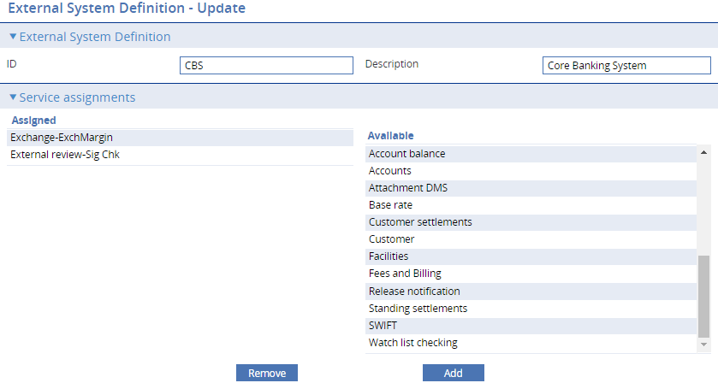

You can then map the external systems to banking entities by using the system tailoring application’s General branch definition|Branch options/Services mappings. Select a Branch and Assign services.

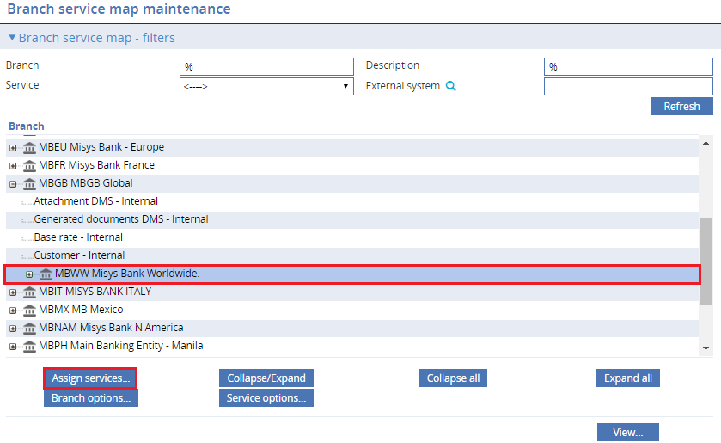

Assign services for external system for this banking entity.

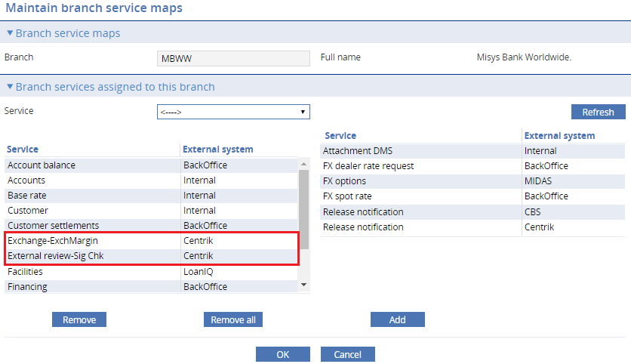

A different external system can be defined for the same steps for transaction with behalf of branches in other entities if your bank is using GlobalProcessing.

